Hp Employment Through the 80’s and 90’s

Presented by April Foolsday emp# 499942

During the task assigned I noticed that the data appeared to be a bit off. These visualizations show how the integrity of the data analyzed may be compromised.

Several of the columns in this data set show there to be an abnormal distribution of names and birth dates. It appears that they are fairly evenly distributed when one may expect them to be less so. As you can see below.

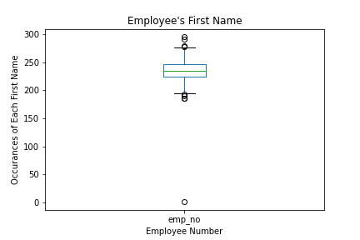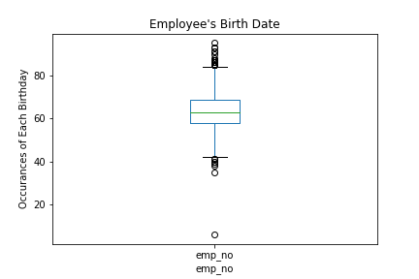

As you can see from above there are a surprisingly large amount of reoccurring first names and birth dates. For example there are 229 occurrences of the first name “Ziyad”, and 258 occurrences of “Zvonko”. I would assume these names to be less common then say John or Jennifer where in fact nether appear at all.

On continued analysis into salaries and salary ranges the distribution does not appear to be consistent.

